./

GENESIS - Learning Outcome & Mini-project Summary Report



|  |  |  |  |  |  |
| --- | --- | --- | --- | --- | --- |
| **Ver. Rel. No.** | **Release Date** | **Prepared. By** | **Reviewed By** | **To be Approved** | **Remarks/Revision Details** |
|  |  |  |  |  |  |
|  |  |  |  |  |  |
|  |  |  |  |  |  |
|  |  |  |  |  |  |
|  |  |  |  |  |  |

**Details**

Contents

Contents 3

Mini Project -1 Team SDLC (System Development life cycle) 4

1.1 Modules Used 4

1.2 Project title: Mini Calculator 4

1.3 Topic and Subtopics 4

1.4 Objectives & Requirements 4

1.4.1 High Level requirement analysis 4

1.4.1 High Level requirement analysis 5

1.5 Design 5

1.5.1 Use Case LLR Diagram 5

1.5.2 Object LLR Diagram 6

1.6 Test Plan 7

1.6.1 High Level Test Plan 7

1.6.2 Low Level Test Plan 7

1.7 Implementation Summary 8

1.8 Video Summary 9

1.9 Git Link 9

1.10 Git Dashboard 9

1.10.1 Badges 9

1.10.2 Git Inspector 9

1.10.3 Setup for Build 11

1.10.4 Outcome of the Build 11

1.10.5 Setup for Code Quality 12

1.10.6 Outcome of Code Quality 12

1.10.7 Setup for Unity Testing 13

1.10.8 Outcome of Unity Testing 13

1.11 Individual Contribution & Highlights 14

1.12 Summary 14

1.13 Challenges faced and how were they overcome 14

Miniproject -2 [Team] 15

Embedded C 15

Topic and Subtopics 15

Objectives 15

Requirements 15

Design 15

Test Plan 15

Implementation Summary 15

Git Link 15

Git Dashboard 15

Summary 15

Individual Contribution & Highlights 16

Summary 16

Challenges faced and how were they overcome 16

# Mini Project -1 Team SDLC (System Development life cycle)

## 1.1 Modules Used

Modules used in this project are SDLC and C programming.

## 1.2 Project title: Mini Calculator

“Modules linked to the miniproject Ex – Linux, SDLC and C++ or SDLC and HTML etc”

## 1.3 Topic and Subtopics

The core steps of SDLC is being implemented.

• The features of Calculator are implemented.

• The testing has been done for each function.

Introduction about SDLC

C Programming

Code Analysis

CPP Check

Valgrind

Testing

Unity Testing

Makefile

V Model

Agile Model

Git Hub

“Briefly list the core topics and subtopics being implemented and how”

## 1.4 Objectives & Requirements

### 1.4.1 High Level requirement analysis

* Any calculator must be efficient.
* Any calculator must have a user-friendly interface.
* It should also be accurate in terms of results.
* It should be able to perform multiple functions.
* It must be cost efficient.

|  |  |  |
| --- | --- | --- |
| ID | Description | Status |
| HLR01 | Area Calculation | Implemneted |
| HLR02 | Volume Calculation | Implemented |
| HLR03 | BODMAS Calculation | Implemented |
| HLR04 | Trigonometry Calculation | Future |
| HLR05 | Logical Calculation | Implemented |
| HLR05 | Exponatial Calculation | Implemented |
| HLR05 | Factorial Calculation | Implemented |
| HLR05 | Diffrentitattion Calculation | Future |
| HLR05 | Integration Calculation | Future |

### 1.4.1 High Level requirement analysis

|  |  |  |
| --- | --- | --- |
| ID | Description | Status |
| LLR01 | For Area  Circle, input=r  Rectangle, input= l,b  Squre, input=l  Triangle, input =b,h | Implented |
| LLR02 | For Volume,  Cube, input =l  Cylinder, input= h,r  Cone, input= h,r  Sphere, input=r | Implented |
| LLR03 | Input = enter equation calculate total based on BODMAS rule | Future |
| LLR04 | If choice =1(sin); input1=a;  choice =2(cos); input1=b;  choice =3(Tan); input1=c; | Implented |

## 1.5 Design

### 1.5.1 Use Case LLR Diagram

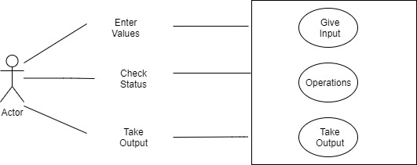

### 1.5.2 Object LLR Diagram

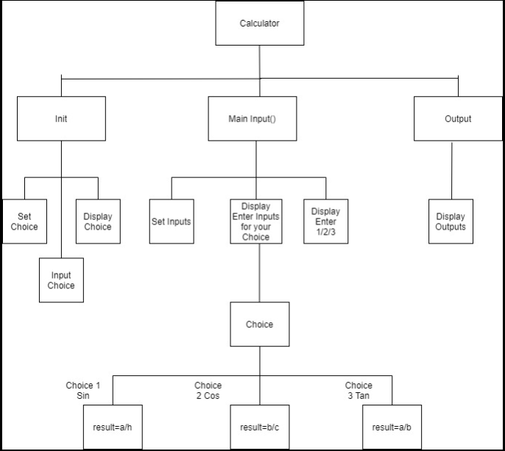

## 1.6 Test Plan

### 1.6.1 High Level Test Plan

|  |  |  |  |  |  |
| --- | --- | --- | --- | --- | --- |
| Test ID | Description | Expected input | Expected Output | Actual Output | Type of Test |
| H_01 | Perform Trignomatric Calculation | 4 | Perform Trignomatric Calculations Based on the Input | Getting right output | Scenario Based |

### 1.6.2 Low Level Test Plan

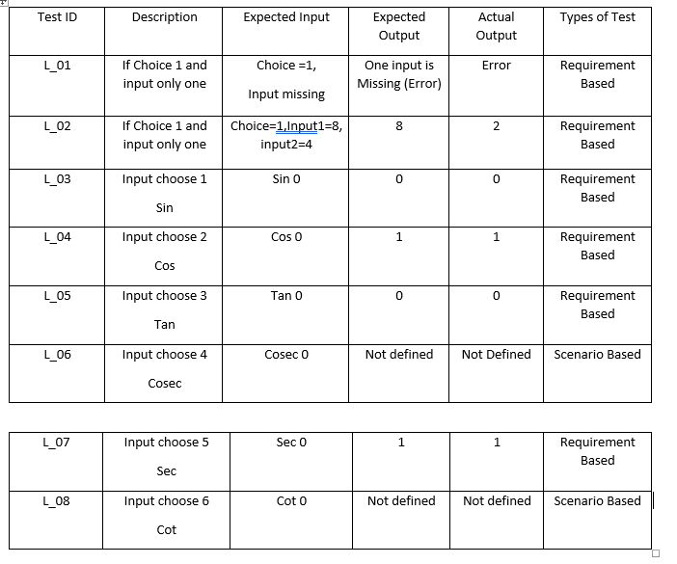

## 1.7 Implementation Summary

It is a basic calculator that will allow users to perform operations in Mathematics Addition, Subtraction, Multiplication, Division, Trigonometry, Factorial, Area, Volume etc. However, the input has to be in the form "number1 operator1 number2 operator2 number3" (i.e 2+4*10). The input values can be from any integer to even a number with decimals. Moreover, this calculator is smart enough to operate multiplication/division before addition/subtraction, in another word it is implemented with the order of precedence logic.

## 1.8 Video Summary

“Please upload a short video on the repo for the walkthrough of the project (Team/Individual) less than 7min and less than 30MB File Size. Start is the Standard opening slide with title of miniproject + Team members followed by the walkthrough”

## 1.9 Git Link

<https://github.com/99003756/NTEAM5_SDLC_CALCULATOR>

## 1.10 Git Dashboard

### 1.10.1 Badges

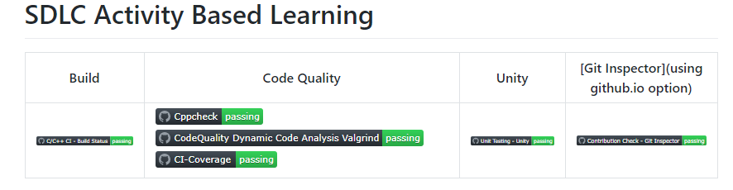

#### Git inspector summary

### 1.10.2 Git Inspector

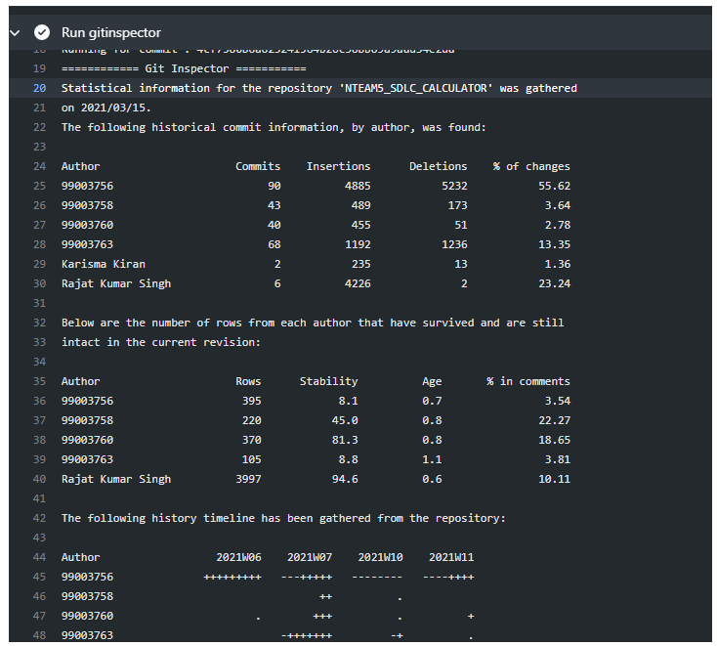

#### Build

### 1.10.3 Setup for Build

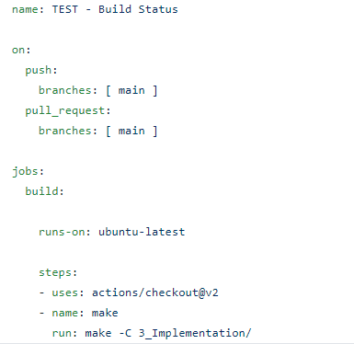

### 1.10.4 Outcome of the Build

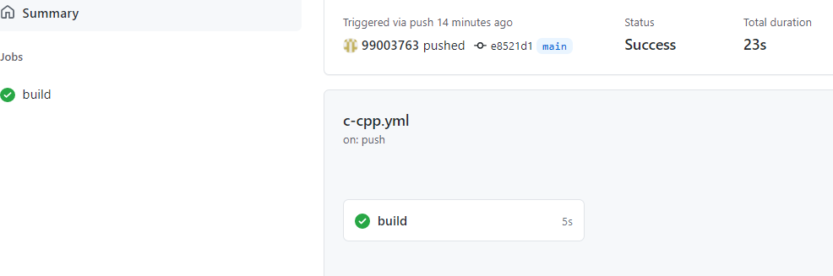

#### 1.14 Code quality and Issues or Bug Tracking

### 1.10.5 Setup for Code Quality

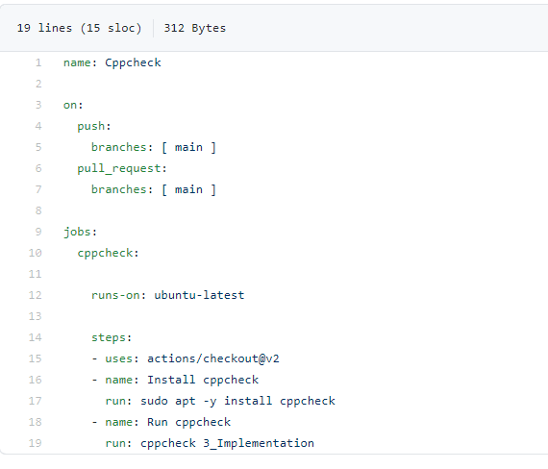

### 1.10.6 Outcome of Code Quality

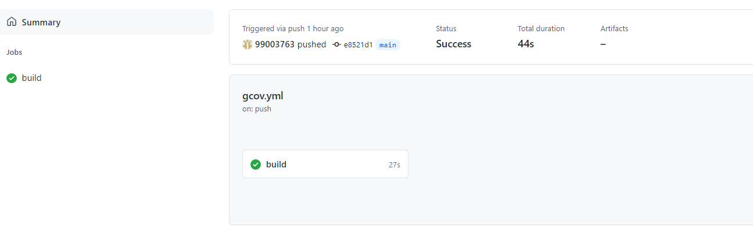

#### 1.15 Unit Testing

### 1.10.7 Setup for Unity Testing

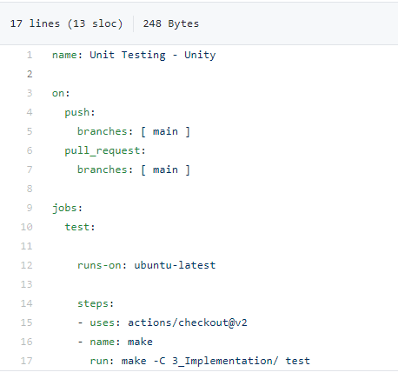

### 1.10.8 Outcome of Unity Testing

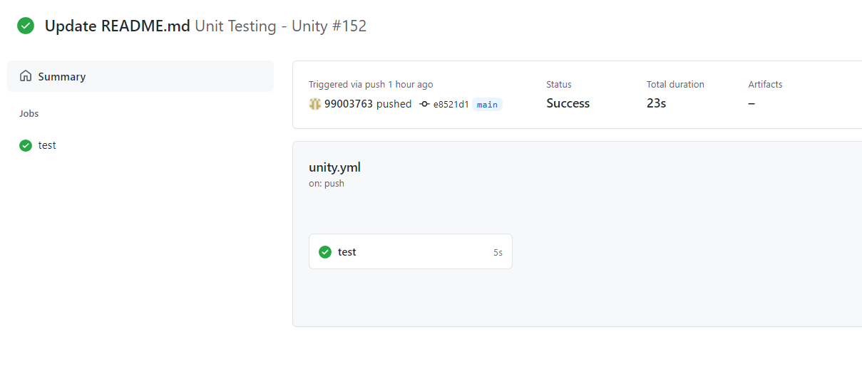

## 1.11 Individual Contribution & Highlights

* Arithmetic, permutation and combination features are implemented.
* Test case for the same is implemented.
* High level and low-level test cases is implemented for the same.
* Issue raised and the issue was solved.
* 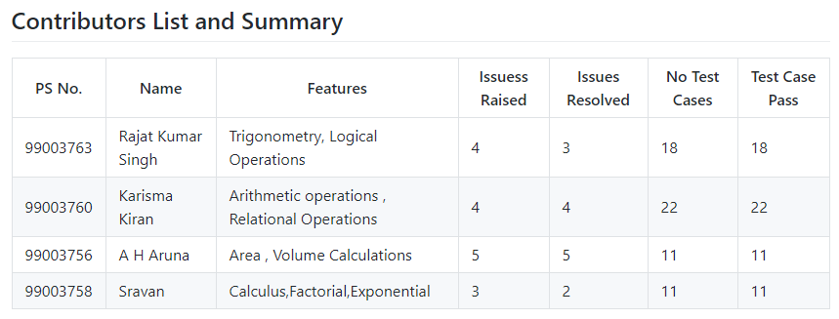Helped during the workflow's implementation of the project.

## 1.12 Summary

### 1.12.1 Outcomes:

Technical:

* Improved implementation of ‘C’ concepts.
* Practical implementation of SDLC lifecycle.
* Source code management. (Github )

Soft skills:

1. Project management

2. Conflict management.

## 1.13 Challenges faced and how were they overcome

* System issues(crashing and Interfacing).
* Differentiation of high level and low level.
* Committing to GitHub, pull and push in GitHub.
* Converting pictures & tables into readme file.
* Cpp check and Unity testing.

# 

# Miniproject -2 Team Embedded C

## Embedded C

### Topic and Subtopics

GPIO Driver Development

Interrupt

STM32 and Arduino programming

## Objectives

To implement functionalities of Body Control Module.

## Requirements

CUBEIDE

STM32 development board

Sensors

LEDs

Jumper wires

Bread board

Push button Switch.

## Design

## Test Plan

## Implementation Summary

### Git Link

### Git Dashboard

### Summary

#### Git inspector summary

#### Build

#### Code quality

#### Unit Testing

#### Issues

## Individual Contribution & Highlights

### Summary

### Challenges faced and how were they overcome

# Miniproject -3 Team Python

### Topic and Subtopics

GPIO Driver Development

Interrupt

STM32 and Arduino programming

## Objectives

To implement functionalities of Body Control Module.

## Requirements

CUBEIDE

STM32 development board

Sensors

LEDs

Jumper wires

Bread board

Push button Switch.

## Design

## Test Plan

## Implementation Summary

### Git Link

### Git Dashboard

### Summary

#### Git inspector summary

#### Build

#### Code quality

#### Unit Testing

#### Issues

## Individual Contribution & Highlights

### Summary

### Challenges faced and how were they overcome